Table of Contents

Table of Contents . . . . . . . . . . . . . . . . . . . . . . . . . . . . . . . . . . . . . . . . . 2
- Introduction . . . . . . . . . . . . . . . . . . . . . . . . . . . . . . . . . . . . . . . . . . . . . .
  - Purpose
  - Scope
    - Description of the problem
    - Current system
    - Goals
  - Definitions, acronyms and abbreviations
    - Definitions
    - Acronyms
    - Abbreviations
  - Revision history
  - Reference documents
  - Document structure
- Overall Description
  - Product perspective
  - Product functions
  - User characteristics
  - Assumptions, dependencies and constraints

1. Introduction
1.1 Purpose
This is the Requirement Analysis ans Specification Document (RASD).
As defined by the IEEE Standards, the goals of this document are to give a complete description of the system-to-be, in terms of both functional and non-functional requirements, to analyse the needs of the costumer in order to model the system, show the constraints blah blah

1.2 Scope
1.2.1 Definition of the problem
TrackMe is a company that wants to develop a software-based service allowing third parties to monitor the location and health status of individuals. This service is called Data4Help. The service supports the registration of individuals who, by registering, agree that TrackMe acquires their data
(data acquisition can happen through smartwatches or similar devices). Also, it supports the registration of third parties. After registration, these third parties can request:
- Access to the data of some specific individuals(we can assume, for instance, that they know an individual by his/her social security number or fiscal code in Italy). In this case, TrackMe passes the request to the specific individuals who can accept or refuse it.
- Access to anonymized data of groups of individuals (for instance, all those living in a certain geographical area, all those of a specific age range, etc.). These requests are handled directly by TrackMe that approves them if it is able to properly anonymize t he requested data. For instance, if the third party is asking for data about 10-year-old children living in a certain street in Milan and the number of these children is two, then the third party could be able to derive their identity simply having people monitoring the residents of the street between 8.00 and 9.00 when kids go to school. Then, to avoid this risk and the possibility of a misuse of data, TrackMe will not accept the request. For simplicity, we assume that TrackMe will accept any request for which the number of individuals whose data satisfy the request is higher than 1000.

As soon as a request for data is approved, TrackMe makes the previously saved data available to the third party. Also, it allows the third party to subscribe to new data and to receive them as soon as they are produced.

Imagine now that, after some time, TrackMe realizes that a good part of its third-party customers wants to use the data acquired through Data4Help to offer a personalized and non-intrusive SOS service to elderly people. Therefore, TrackMe decides to build a new service, called AutomatedSOS, on top of Data4Help. AutomatedSOS monitors the health status of the subscribed customers and, when such parameters are below certain thresholds, sends to the location of the customer an ambulance, guaranteeing a reaction time of less than 5 seconds from the time the parameters are below the threshold.
1.2.2 Current System
TrackMe has no pre-existing services that need to be integrated with the new ones, Data4Help and AutomatedSOS. The whole system-to-be is going to be build completely from scratch, therefore no current system will be considered during the design process.
1.2.3 Goals
- G1:
- G2:
- G3:
1.3 Definitions, acronyms and abbreviations
1.3.1 Definitions
1.3.2 Acronyms
1.3.3 Abbreviations

- Gn: the goal number n.
- Dn: the domain assumption number n.
- Rn: the functional requirement number n.

1.4 Revision history
At the moment there is no revision history to show, as this current version is the only existent one.

1.5 Reference documents
- Specification document: “Mandatory Project Assignment AY 2018-2019”
- IEEE Std 830-1993 - IEEE Guide to Software Requirements Specifications
- IEEE Std 830-1998 - IEEE Recommended Practice for Software Requirements Specifications

1.6 Document structure
This document is composed by seven main parts, including a final appendix.

- Introduction. In the first part the problem is presented, with all the main basic information needed to fully understand the scope and the objective of the document itself. All the goals of the system-to-be are already specified and explained.
- Overall Description. The second part is a comprehensive general description of the system: there is the presentation of its boundaries and the specification the main actors that will use the system itself.
- Specific Requirements. The third part is a precise specification of the aspects already discussed in the previous section, in order to clarify the details for the development team. There is here an identification of every specific requirement, functional or non-functional. Furthermore, here is the use case diagrams, use cases, performance analysis, design constraints and finally the attributes of the software system.

- Analysis or the System. The fourth part provides a more formal analysis of the system, using both formal and semi-formal approaches (respectively, using Alloy). A more rigorous approach is used to define the critical aspects of the system.
- Appendix. The fifth and last part comprehends a list the tools used to redact this document and its contents and a detailed report of the hours and efforts spent by each member of the group during the project.

2. Overall Description
2.1 Product perspective

2.2 Product functions
2.3 User characteristics
2.4 Assumptions, dependencies and constraints

- Specific Requirements
  - External Interface Requirements (add pictures)
In this section we will specify how the modules of this system will interact the one to each other.
    - User Interfaces
Since the application only gather data about health status and position it only needs to be downloaded from the store, to allow registration of your type (individual or third party), check login credentials and then run in background. If it is a third party request access to data. (page when user can control the tracking permission to each third party)
    - Hardware Interfaces
The hardware component (smartwatches) will be worn every day.
    - Software Interfaces
The core of the system will reside in a central computer (server) which registers the user in the database, allows the safe login, receive updated on a regular basis. There is an interface between the system and third-party enterprises: the incoming requests will be therefore processed then allowed or denied.
    - Communication Interfaces
The connection between the modules employs the Web.
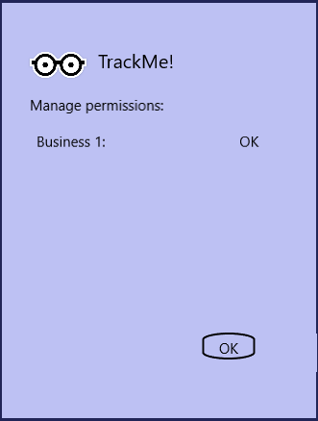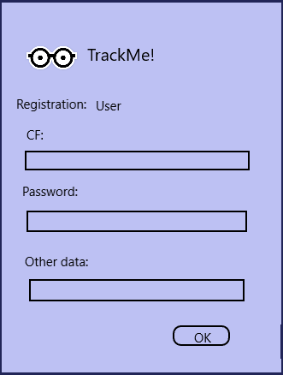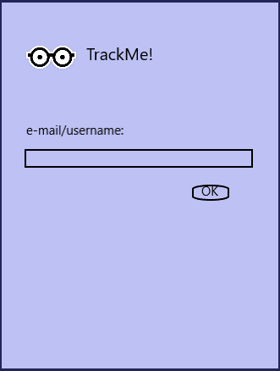

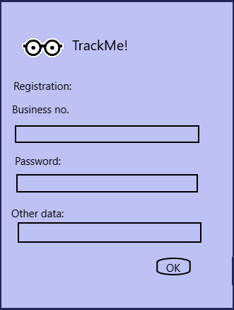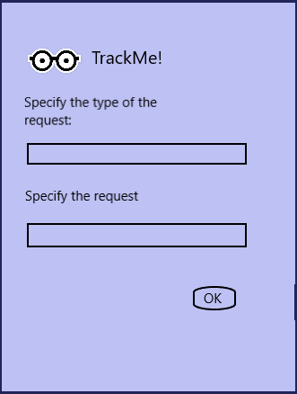

  - Functional Requirements
Here we will define the use case diagrams, use cases and the full state diagrams, the Goal we expect to fulfil, and the mapping on the requirements.
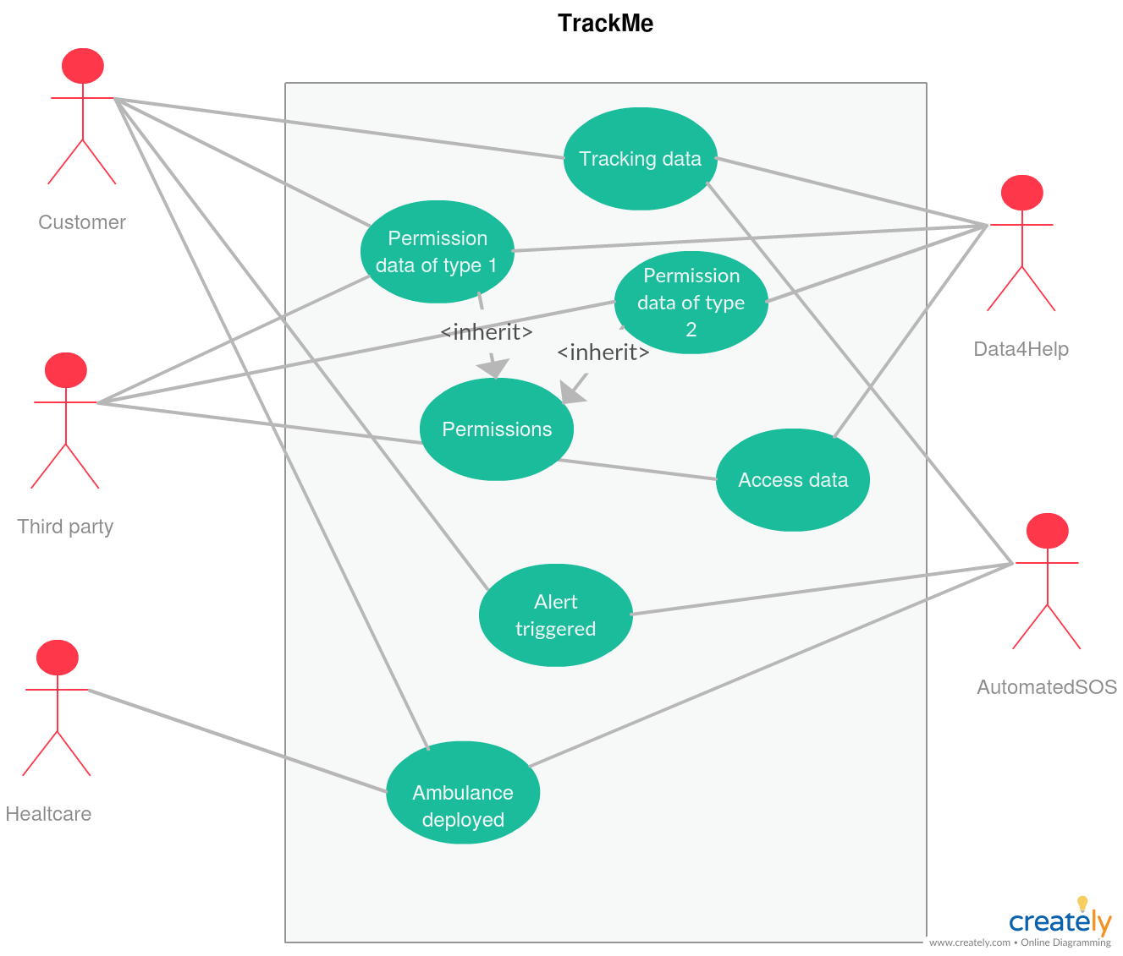
      - General use case diagram

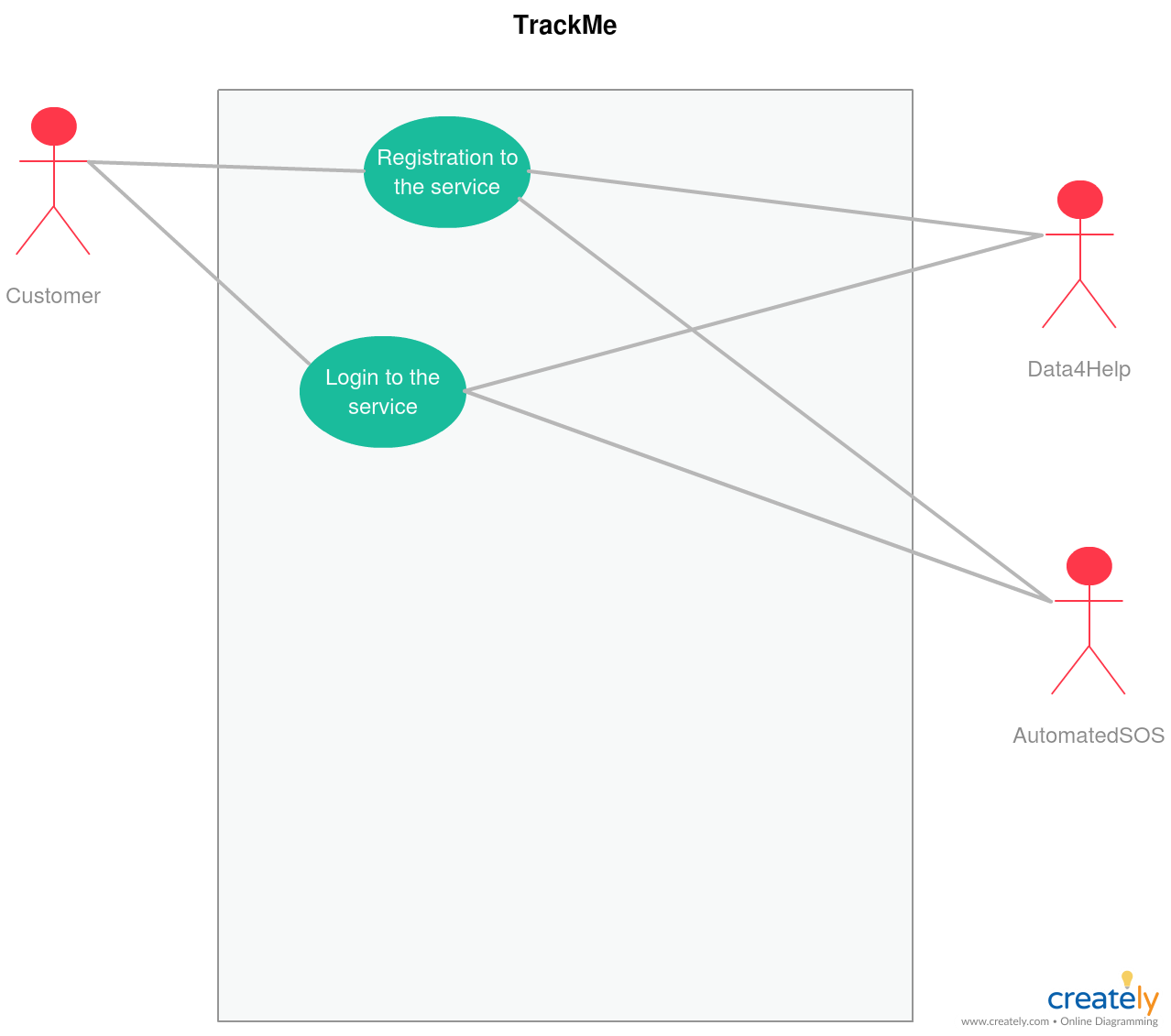
      - User use case diagram

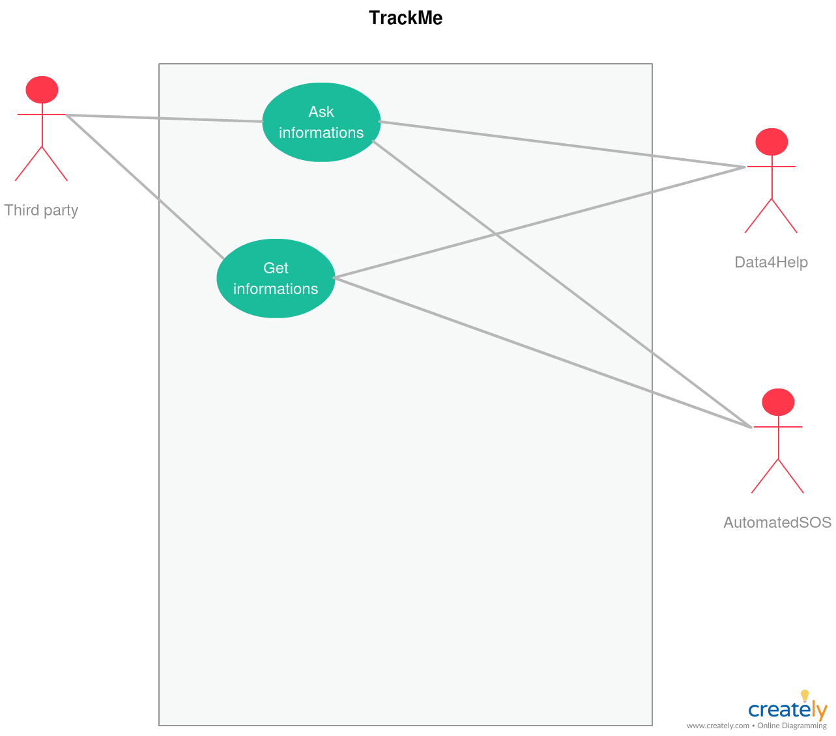
      - Third party use case diagram

    - Proper functional requirements
      - G1. Allow the registration of the user
            - R1: The user must have an email prior to registration
            - R2: The user must have the app installed on his smartwatch
            - R3: The user must have a non-hacked app
            - D1: The e-mail must be unique
            - D2: The username must be unique
            - D3: The fiscal code must be unique
      - G2. Allow the tracking and subsequent storing of data
            - R1: The user must have given his consent to the tracking
            - R2: The user must be logged in
            - D1: The GPS is turned on and enabled
            - D2: The GPS must allow a high precision even when the user is in non-open spaces
      - G3. Guarantee the data privacy protection
            - R1: The user should keep the password of its account secret
            - R2: The third party app doesn’t allow leaked data
            - D1: The third party has signed a NDA (non-disclosure-agreement)
            - D2: The connection is fully encrypted
            - D3: The data stored on the server are inaccessible from a third party
            - D4: The data stored on the server are not in plain-text
      - G4. Allow the registration of the third parties
            - R1: R1: The user must have an email prior to registration
            - R2: The user must have the app installed on his smartwatch
            - R3: The user must have a non-hacked app
            - D1: The e-mail must be unique
            - D2: The username must be unique
            - D3: The number of the business must be unique
            - D4: The business must be legally recognized
      - G5. Allow the third party to ask users’ data
            - R1: The business must specify the type of the request
            - R2: The third party must be logged into the system
            - D1: The third party knows the fiscal code of the individual he wants to inquire about
            - D2: The system will deny a generalized request with less than 1000 individuals
      - G6. The system must be able to promptly detect harmful events
            - R1: The user must wear the smartwatch always, if he wants seamless protection
            - R2: The user must be logged in to use this function
            - D1: At least a computational unit must be on in every moment
            - D2: The system must be ready to accept every alert in every moment
            - D3: The health parameters are not distorted
            - D4: The position must be trusted
      - G7. An ambulance must be deployed within specified time constraint
            - R1: The ambulance dept. of the system is connected to the server system
            - R2: The manager of this kind of request must have higher priority than the others
            - R3: The ambulance must stay connected for all the time with the system manager
            - D1: The place where help is needed is reachable by earth-way
            - D2: The ambulance must be able to change destination as the system manager might update the position. (The illness may happen when the user is in the car, which is moving)

    - Use cases (explain what to do when exceptions occur)
      - Individual registration
ACTORS | Future user
GOALS | G1
INPUT CONDITIONS | -The user is not previously registered
EVENTS FLOW | -The user inserts e-mail and password  -The user clicks on the “Enter” button  -The user clicks on the individual button  -The user inserts its personal data (e.g. fiscal code) which will be validated prior to effective creation of account.
OUTPUT CONDITIONS | -The user is granted service of the application by logging-in
EXCEPTIONS | -Internet connection interrupted  -The user is already registered.  -Password chosen doesn’t fulfil the constraints on it  -User doesn’t follow the link on the confirmation e-mail afterwards

      - User login
ACTORS | Current user
GOALS | G2
INPUT CONDITIONS | The user is already registered
EVENTS FLOW | -The user inserts e-mail and password  -The user clicks enter  -The system detects that the user is already registered  -The app shows the “Stop tracking” button and the notification bar
OUTPUT CONDITIONS | Tracking starts
EXCEPTIONS | -Internet connection interrupted
      - Third party registration
ACTORS | Future third party user
GOALS | G4
INPUT CONDITIONS | -The user is not previously registered
EVENTS FLOW | -The user inserts e-mail and password  -The user clicks on the “Enter” button  -The user clicks on the third-party button  -The user inserts its personal data (e.g. Business number) which will be validated prior to effective creation of account.
OUTPUT CONDITIONS | -The user is granted service of the application by logging-in
EXCEPTIONS | -Internet connection interrupted  -The user is already registered.  -Password chosen doesn’t fulfil the constraints on it  -User doesn’t follow the link on the confirmation e-mail afterwards
      - Third party login
ACTORS | Current user
GOALS | G5
INPUT CONDITIONS | The user is already registered
EVENTS FLOW | -The user inserts e-mail and password  -The user clicks enter  -The system detects that the user is already registered  -The app shows the “Stop tracking” button and the notification bar
OUTPUT CONDITIONS | User can start requesting data
EXCEPTIONS | -Internet connection interrupted
      - App tracking at work
ACTORS | User
GOALS | G2
INPUT CONDITIONS | User successfully logged-in
EVENTS FLOW | No further actions needed here
OUTPUT CONDITIONS | Data being forwarded to the server
EXCEPTIONS | -GPS signal absent  -Sensors not working properly
      - Request to access private data
ACTORS | Third party
GOALS | G5
INPUT CONDITIONS | Third party is logged in
EVENTS FLOW | Third party sends request to the server specifying CF and the type of data he wants to access with “-subscribe” option
OUTPUT CONDITIONS | The request is sent
EXCEPTIONS | -CF does not exist  -Malformed request
      - User permission about the personal data request

ACTORS | User
GOALS | G3
INPUT CONDITIONS | A request to receive data and updates is pending user approval
EVENTS FLOW | -User gets notified about the request  -User open the application, goes to the notification area and approve it or refuse it, considering the “-subscribe” option
OUTPUT CONDITIONS | The request is approved or denied
EXCEPTIONS | No exceptions: in case of connection problems the answer is cached and sent when connection is obtained
      - Request to access generalized data
ACTORS | Third party
GOALS | G5
INPUT CONDITIONS | Third party is logged in
EVENTS FLOW | Third party sends request to the server specifying the number of people () and the type of data he wants to access with “-subscribe” option
OUTPUT CONDITIONS | The request is sent
EXCEPTIONS | -Malformed request
      - System permission about the generalized data request

ACTORS | User
GOALS | G3
INPUT CONDITIONS | A request to receive generalized data and updates is pending system approval
EVENTS FLOW | System automatically approves or refuse request
OUTPUT CONDITIONS | The request is approved or denied
EXCEPTIONS | No exceptions: in case of connection problems the answer is cached and sent when connection is obtained
      - Vital parameters drop below alert threshold and the help-request is triggered
ACTORS | User
GOALS | G6
INPUT CONDITIONS | Actual vital parameters fall
EVENTS FLOW | -The application become aware of the critical situation  -The help-request is sent to the server, providing location of the patient and which parameters have fallen
OUTPUT CONDITIONS | The server processes the request
EXCEPTIONS | -The time constraints are not satisfied  -GPS not working
      - Ambulance deployed when help-request gets the server
ACTORS | Emergency dept.
GOALS | G7
INPUT CONDITIONS | Help-request received from a user
EVENTS FLOW | System elaborate the position of the user and send the position of the user along with the status of the patient
OUTPUT CONDITIONS | The ambulance gets the user within the time constraints
EXCEPTIONS | -High congestion causing delays  -Ambulance involved in car accident  -Technical issues of the ambulance

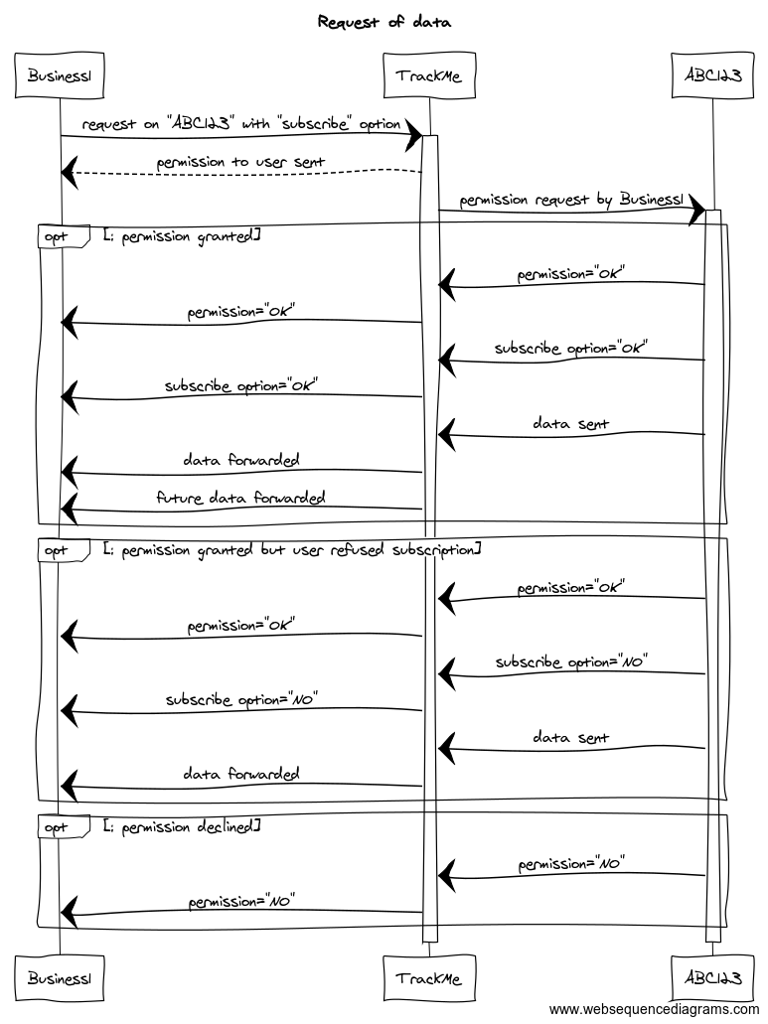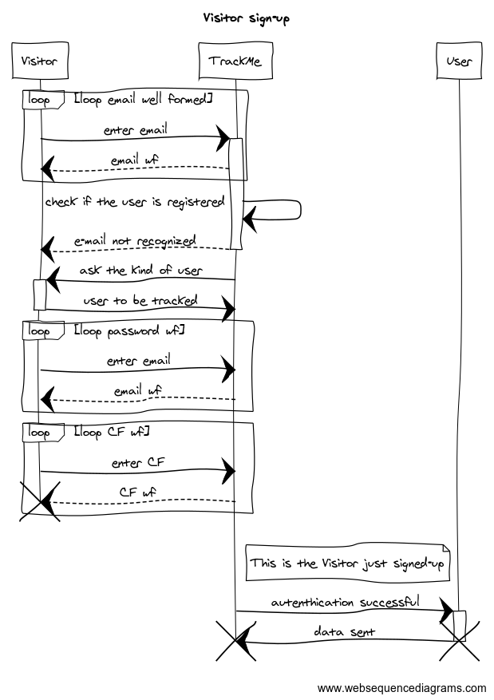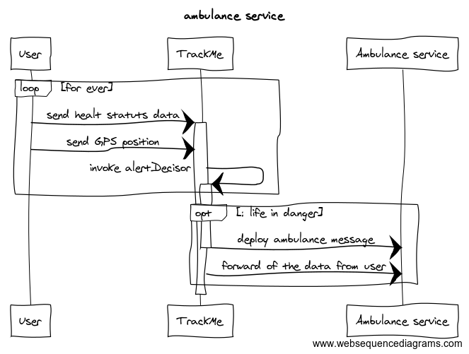

    - Full state diagram
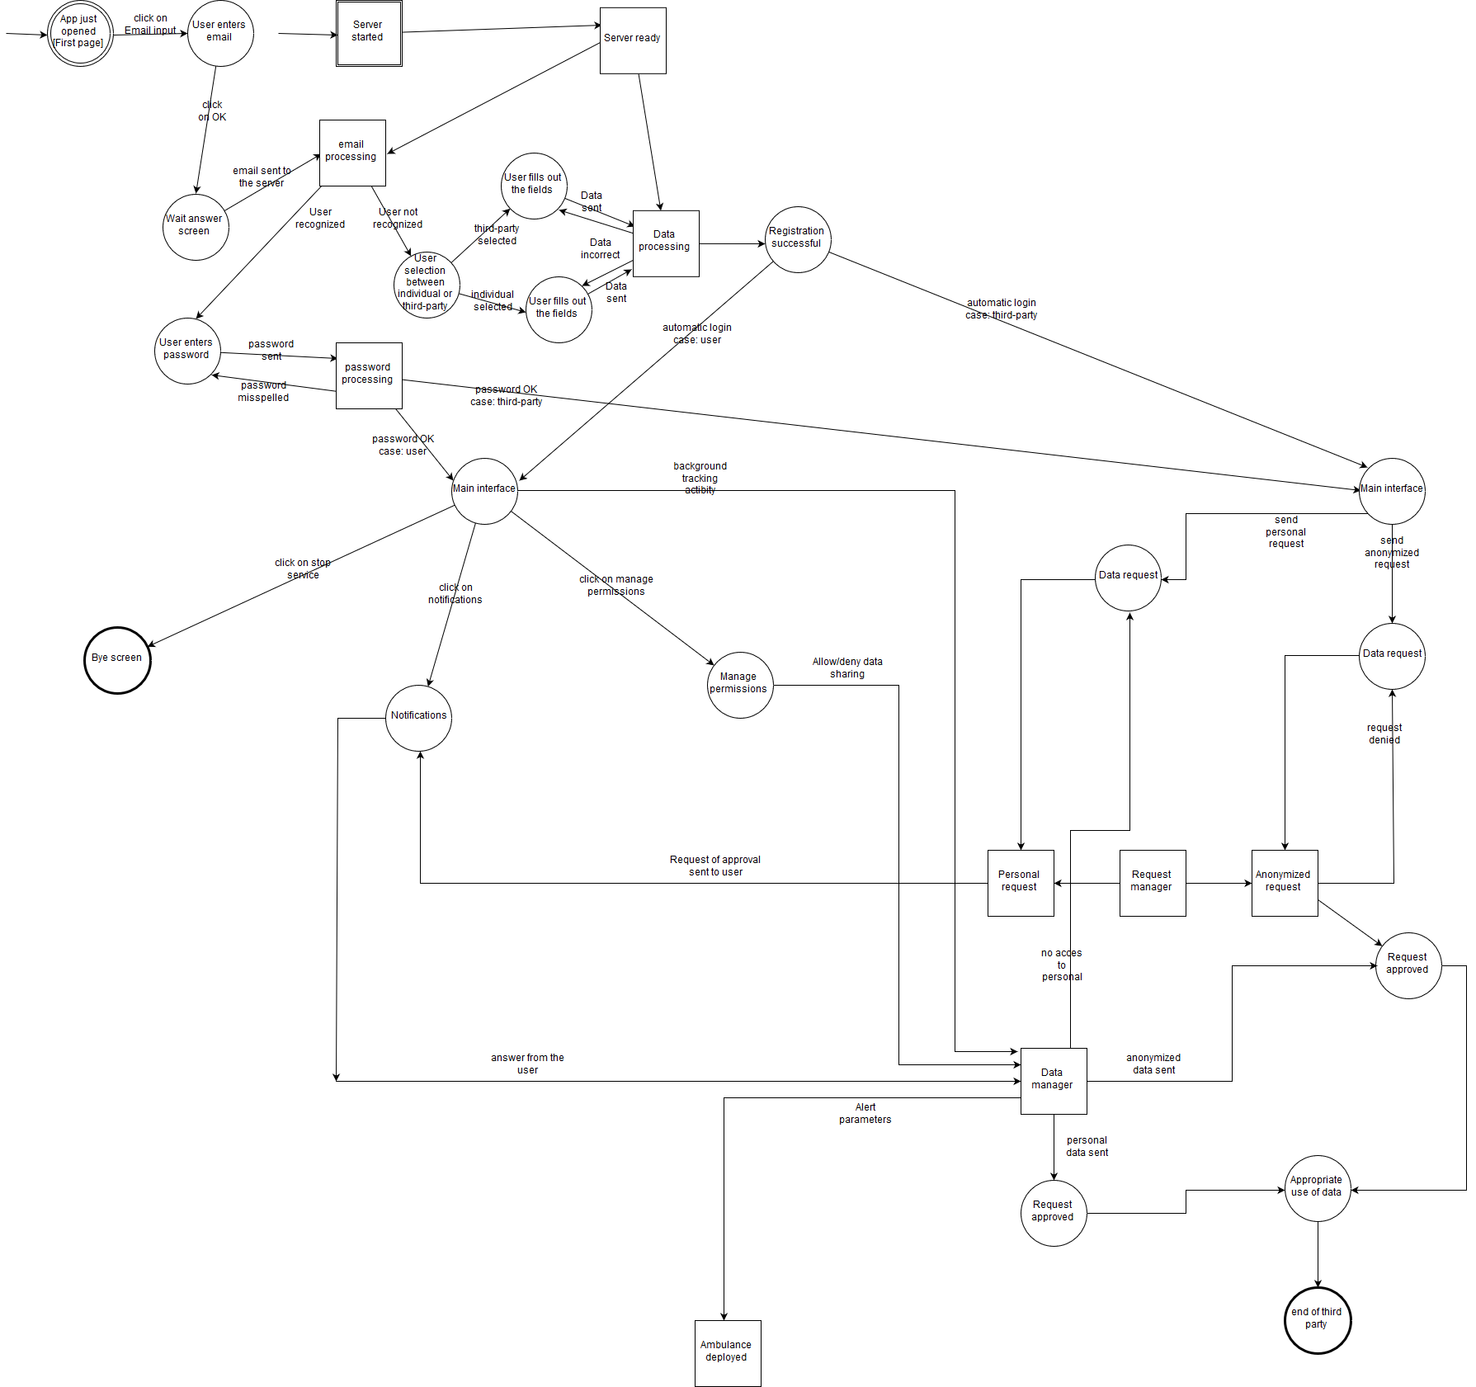
      - Entire

      - 1 part
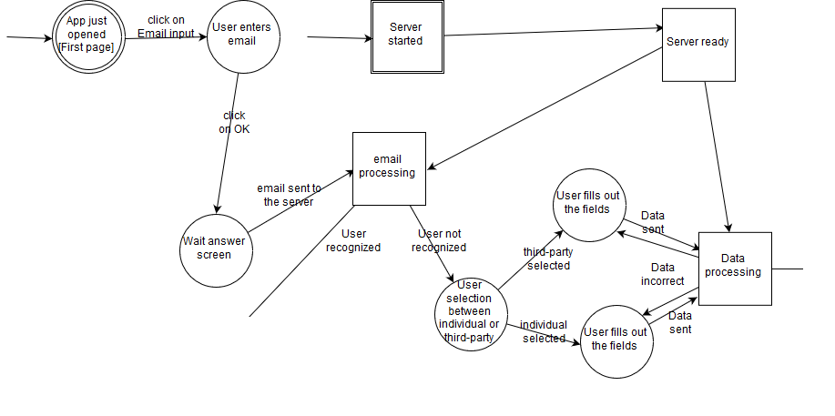
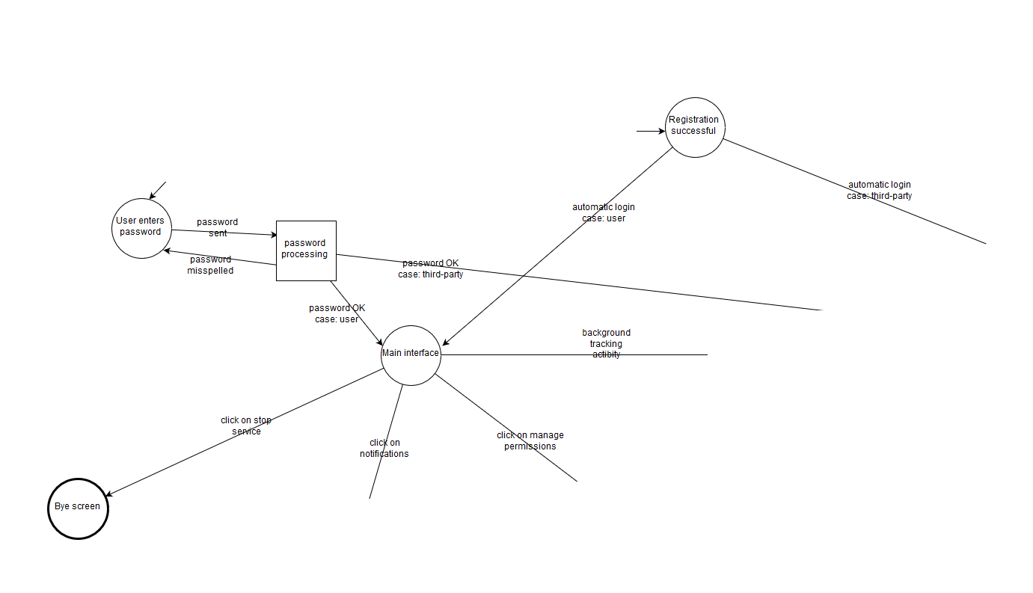
      - 2 part

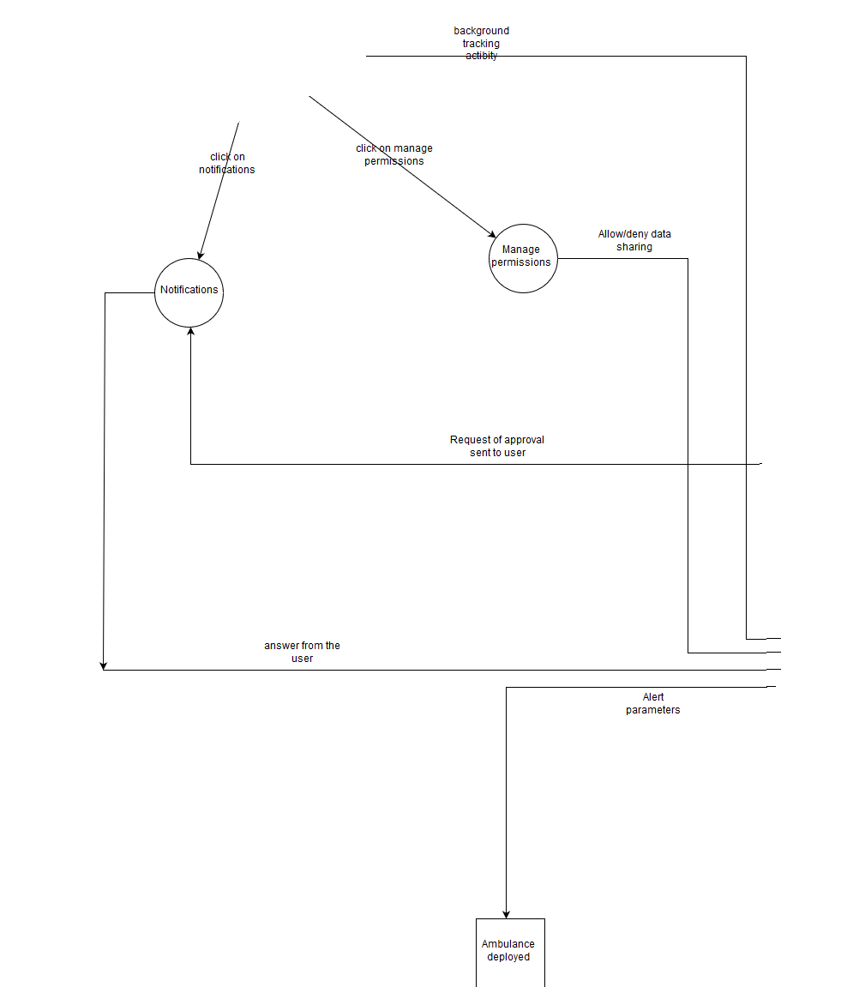
      - 3 part

      - 4 part

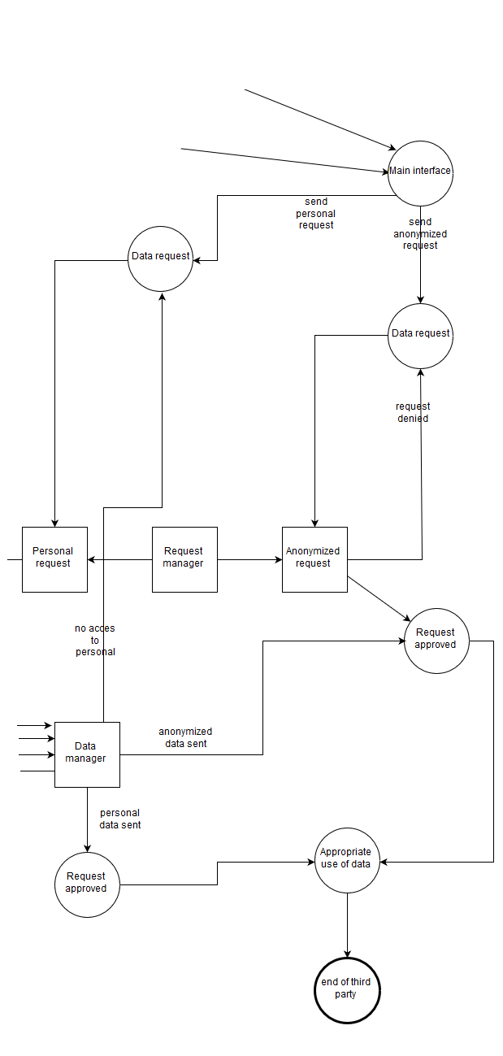

    - Performance requirements

      - Use case scenario
        - Alice sees this new app, and she thinks she can give it a try. So she suggest to her boyfriend Bob to join her and sign up into the system. They then provide the requested data and agree on the permission of tracking the position and the personal data.
After registration they login to the platform and wear the smartwatch.
        - Tracking business is a newly started business, which acquires data from the users and share them. Thomas is the head of this firm and he thinks it might be a good idea to join the platform. So he download the app, and then he register himself. The idea of registering as a user, not only as a third party came across his mind, but he prefers to not be tracked.
After the data are entered into the system, he can start by logging in the platform.
        - The business of Thomas in now connected to the network of TrackMe. He decides then to make his first request. He starts by choosing a type of request: it can be a generalized one or a specific one.
It follows now the confirmation by the system and the user, eventually, and if it is approved Thomas can start doing his business exploiting the data gathered.
        - It happens now that Thomas’ business makes a request. This request reaches the system. Let’s suppose the request, is of a specific user. Then the system request the user to choose if it will allow the business to get his data. The user will be notified by that and he can choose yes or no. The user will be able to deny the permission later, eventually. Suppose instead that Thomas wants to inquire about a generalized amount of data. Then the system will get the number of requests and evaluates whether the request is appropriate or not.
        - Bob is an old user. He doesn’t love the fact that data is always being sent but appreciates the emergency system. He is sure that if there will be an app which performs only the emergency system he will choose that one. But as long as this is the only available app, he chose this one. Out of the blue he doesn’t fell very well, his breath frequency is becoming low, and the pressure drops in free fall. But Bob is provident, the smartwatch he always wears detects the imminent problem and send the emergency message to the system. The system then will promptly send an ambulance to rescue him.

When it comes to performance requirements, we can speak about two main areas: Computational complexity and the capabilities of the system.
      - Computational complexity
Find an email will take being the number of user.
The search algorithm will be a binary search and therefore the insert of a new user must be in order.
The insertion time will be again a , adopting a slightly modified version of the binary search with a lexicographic ordering criterion defines a total ordering relation which is defined as follows: we have , and if being the smallest index in which they differ. If instead there not exists a such , which is the case when , then we must have .
The deletion time is in the same complexity of the search time.
Every other action is straightforward (constant time) when a object is found
      - Capabilities of the system
The system is expected to handle at least 10000 users.
    - Design constraints
      - Standard compliance
The strictest request is to send an ambulance within 5 secs. Of course every user/ third party expects to be notified of the answer of the other in a reasonable time.
      - Hardware limitations
???
      - Any other constraints

    - Software system attributes
      - Reliability
The reliability is of the main importance especially when the system detects a harmful situation. It is not mandatory when messages are sent.
      - Availability
As above, the system, the ambulance dept. must be available for all the time the system is needed. The forwarding of the tracked data instead is not mandatory to be always available, data can be cached and sent later.
      - Security
The security is one of the main topics, since we are dealing with personal data of the customers. A close sight will be dedicated to this issue in the implementation phase, and countermeasures must be taken in case an intrusion is detected.
      - Maintainability
For the application to be scalable we must have every system in the network seen as a functional module. In this case maintain and detect bugs should be easier. Very closely related to this is the scalability: in case we see the necessity of an expansion a modular system suits well the replacing of a subsystem or a module itself.
      - Portability
The portability is obtained by using a language cross-platform such as Java. It is easy to install a Java Virtual Machine and then run the program. A future expansion foresee a web based service for the third party, the compatibility problems for it can be then reduced substantially.

7. Appendix
7.1 Used tools

- OpenOffice Writer
- StarUML
- Microsoft Office 365
- Creately

7.2 Hours of work
7.2.1 Giorgio Polla

DATE | TASK | HOURS

7.2.2. Alberto Tiraboschi
DATE | TASK | HOURS
21/10/2018 | Outline of the chapter | 2
28/10/2018 | Use case diagrams produced, outline of the goals and merge of papers in one file | 6

